第六讲 Channel——Part I 2025.9.22
Example1:Assume the transmitted power ${\text{P}}_{\text{T}}\text{=10 W}$, transmitting antenna gain ${\text{G}}_{\text{T}}\text{=100}$, receiving antenna gain ${\text{G}}_{\text{R}}\text{=10}$. The propagation distance is $\text{50 km}$, and the electromagnetic wave frequency is $\text{800 MHz}$. Calculate the received power and propagation loss.

Example 2: A binary symmetric memoryless channel (BSC). Bit 0 and bit 1 are transmitted with equal probability. The error transition probabilities are $\text{P}\text{(1|0)=}\text{P}\text{(0|1)=0.005}$. Calculate the average bit error probability ${\text{P}}_{\text{e}}$.
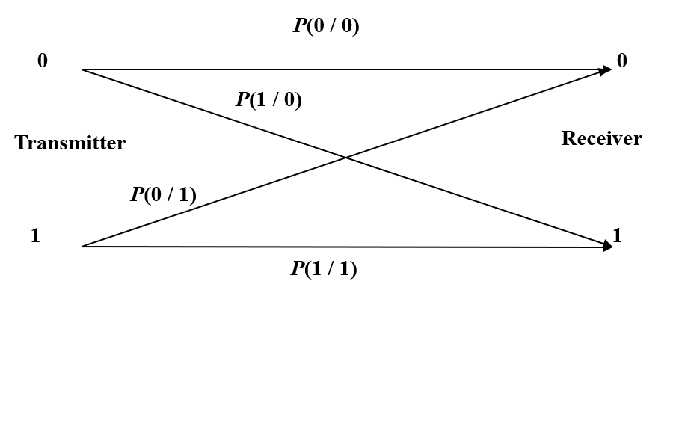

True & False
( ) 1. The modulation channel is located between the output of the modulator and the input of the demodulator.
( ) 2. The coding channel mainly analyzes waveform distortion and amplitude-frequency distortion of analog signals.
( ) 3. The performance of the coding channel depends on the noise and distortion from the modulation channel.
Short answer question:
What is the difference between modulation channel and coding channel?

Example 3 : A two-path multi-path channel, the channel transfer function is
$\text{H}\text{(}\text{ω}\text{)=}\text{A}{\text{e}}^{\text{−}\text{jω}{\text{τ}}_{\text{0}}}\left(\text{1+}{\text{e}}^{\text{−}\text{jωτ}}\right)$ The relative time delay between two paths is $\text{τ}\text{=2 }\text{μs}$.
- Find the frequencies where deep fading (nulls零点) happens.
- Calculate the coherence bandwidth of this two-ray channel.

No. | English | 中文
1 | attenuation | 衰减
2 | propagation | 传播
3 | symmetrical cable | 对称电缆
4 | coaxial cable | 同轴电缆
5 | optical fiber | 光纤
6 | ground wave | 地波
7 | sky wave | 天波
8 | LOS (line of sight) | 视距传播
9 | constant parameter channel | 恒参信道
10 | random parameter channel | 随参信道
11 | frequency selective fading | 频率选择性衰落
表1 专业词汇中英文对照

